# Apply filters to SQL queries

## Project description

My team wants data to investigate potential security issues and to update computers. So, I am responsible for filtering the required information from the database by which I need to obtain specific information about employees, their machines, and the departments they belong to from the database.

## Retrieve after-hours failed login attempts

Query: SELECT *

-> FROM log_in_attempts

-> WHERE login_time > '18:00' AND success = 0;

Output: 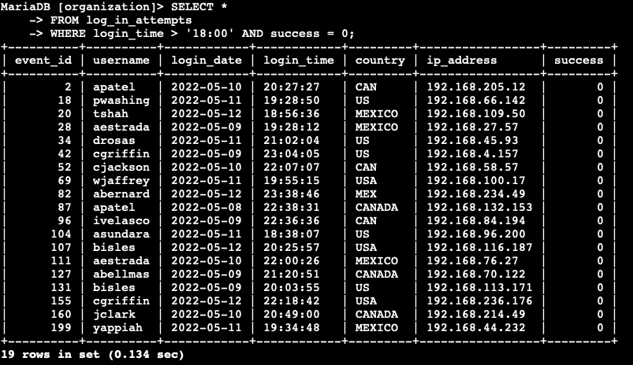

## Retrieve login attempts on specific dates

Query: SELECT *

-> FROM log_in_attempts

-> WHERE login_date = '2022-05-09' OR login_date = '2022-05-08';

Output: 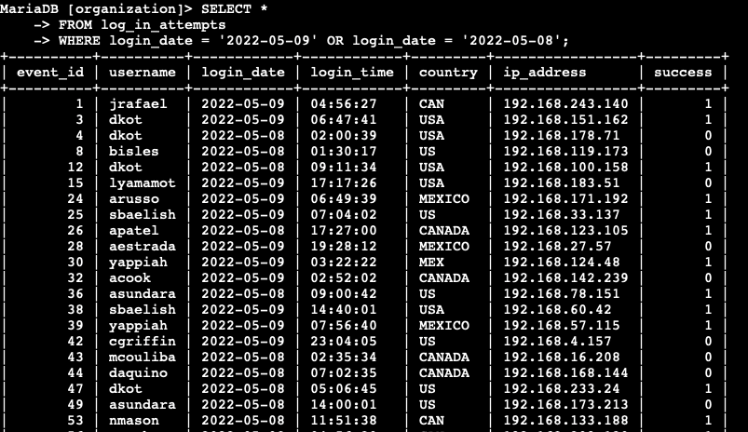

## Retrieve login attempts outside of Mexico

Query: SELECT *

-> FROM log_in_attempts

-> WHERE NOT country LIKE 'MEX%';

Output:

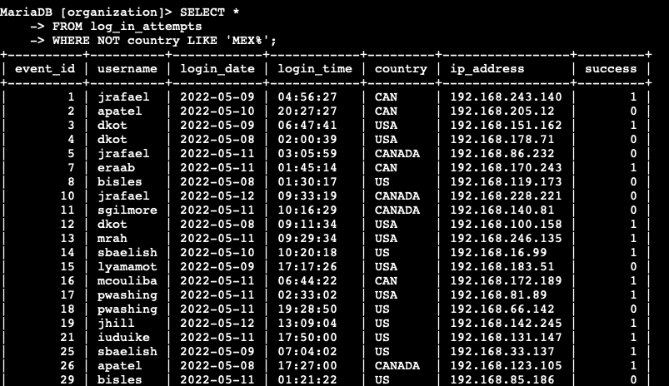

## Retrieve employees in Marketing

Query: SELECT * FROM employees WHERE department LIKE 'Marketing' AND office LIKE 'EAST%';

Output: 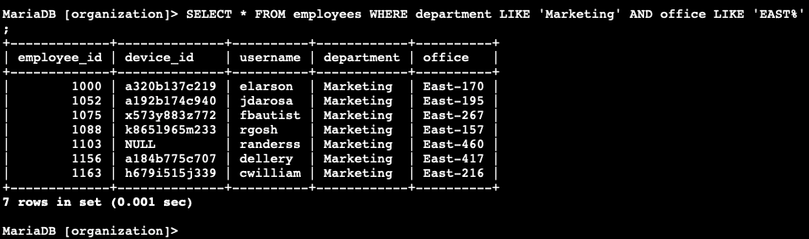

## Retrieve employees in Finance or Sales

Query: SELECT * FROM employees WHERE department LIKE 'Finance' OR department LIKE 'Sales';

Output: 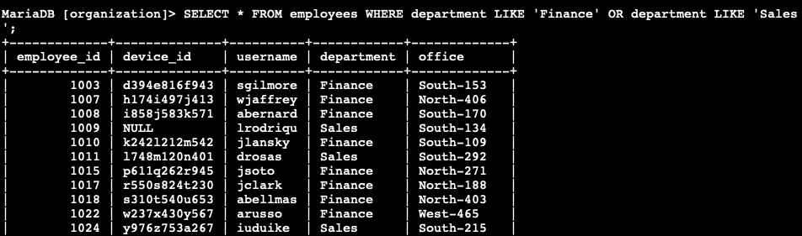

## Retrieve all employees not in IT

Query: SELECT * FROM employees WHERE NOT department LIKE 'Information Technology';

Output: 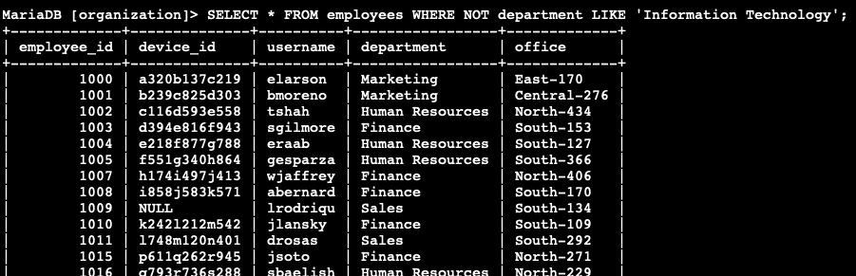

## Summary

The filtration of the required data from the database includes various tasks. They’re first I’ll retrieve all failed login attempts after business hours. Second, I’ll retrieve all login attempts that occurred on specific dates. Third, I’ll retrieve logins that didn't originate in Mexico. Fourth, I’ll retrieve information about certain employees in the Marketing department. Fifth, I’ll retrieve information about employees in the Finance or the Sales department. Finally, I’ll obtain information about employees not in the Information Technology department.